PIZZA SALES SQL QUERIES
A.KPI’s
1.Total Revenue:
select SUM(total_price) as Total_Revenue from pizza_sales_csv
output:
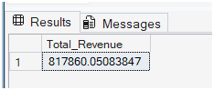
2.Average Order Value:
select SUM(total_price)/ COUNT(distinct order_id) as Avg_order_value FROM pizza_sales_csv
output:
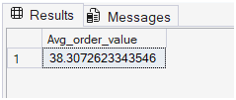
3.Total pizzas sold:
select SUM(quantity) as Total_pizza_sold FROM pizza_sales_c
output:
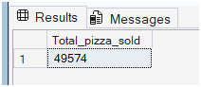
4.Total orders:
select COUNT(distinct order_id) as Total_orders FROM pizza_sales_csv
output:
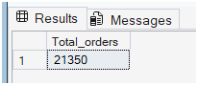
5.Average pizzas per order:
SELECT CAST(CAST (SUM(quantity) as decimal (10,2))/CAST (COUNT(DISTINCT order_id) as decimal (10,2))as decimal (10,2)) as Avg_pizzas_per_order FROM pizza_sales_csv
output:
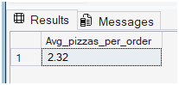

B. Chart’s Requirement:
1.Daily Trend for Total orders:
SELECT DATENAME(DW,order_date) as order_day,COUNT(DISTINCT order_id) as Total_orders FROM pizza_sales_csv
GROUP BY DATENAME(DW,order_date)
output:
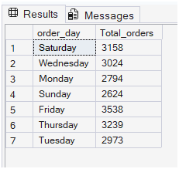
2.Monthly trend for Total orders:
SELECT DATENAME(MONTH,order_date) as Month,COUNT(DISTINCT order_id) as Total_orders
FROM pizza_sales_csv
GROUP BY DATENAME(MONTH,order_date)
ORDER BY Total_orders DESC;4
output:
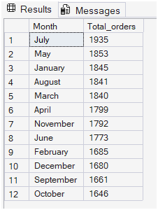
3.Percentage of sales by Pizza category:
SELECT pizza_category,SUM (total_price) AS Total_sales,SUM(total_price)*100/(SELECT SUM(total_price) FROM pizza_sales_csv) AS Percent_of_Total_sales
FROM pizza_sales_csv
GROUP BY pizza_category;
output:
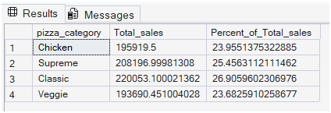
4.Percentage of sales by Pizza size:
SELECT pizza_size,SUM(total_price)as Total_sales, CAST(SUM(total_price)*100 / (SELECT SUM(total_price) from pizza_sales_csv) AS DECIMAL (10,2)) as PCT FROM pizza_sales_csv
Group by pizza_size
ORDER BY PCT Desc;
output:
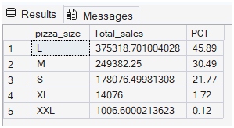
5. Total pizzas sold by Pizza category:
SELECT pizza_category,SUM(quantity)AS Total_pizzas_sold FROM pizza_sales_csv
GROUP BY pizza_category
ORDER BY Total_pizzas_sold Desc;
output:
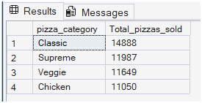
6.Top 5 Pizzas by Revenue:
SELECT TOP 5 pizza_name,SUM(total_price) as Total_revenue
FROM pizza_sales_csv
GROUP BY pizza_name
ORDER BY Total_revenue desc;
output:
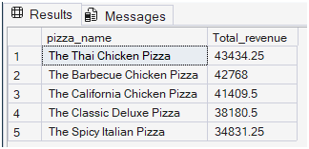

7.Bottom 5 Pizzas by Revenue:
SELECT TOP 5 pizza_name,SUM(total_price) as Total_revenue
FROM pizza_sales_csv
GROUP BY pizza_name
ORDER BY Total_revenue asc;
output:
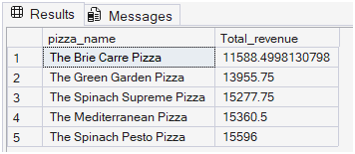
8.TOP 5 Pizzas by Items sold/Quantity :
SELECT TOP 5 pizza_name,SUM(quantity) as Total_pizzas_sold
FROM pizza_sales_csv
GROUP BY pizza_name
ORDER BY Total_pizzas_sold desc;
Output:
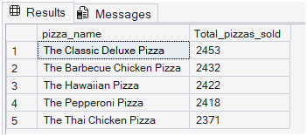
9.BOTTOM 5 pizzas by Items sold/Quantity:
SELECT TOP 5 pizza_name,SUM(quantity) as Total_pizzas_sold
FROM pizza_sales_csv
GROUP BY pizza_name
ORDER BY Total_pizzas_sold asc;
output:
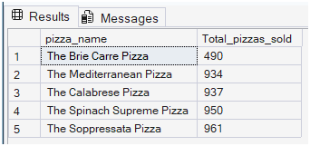
NOTE:
1.Total sales, PCT for Jan month:
SELECT
pizza_category,
SUM (total_price) AS Total_sales,
SUM(total_price)*100/(SELECT SUM(total_price)FROM pizza_sales_csv WHERE MONTH(order_date)=1) AS Percent_of_Total_sales
FROM pizza_sales_csv
WHERE MONTH(order_date) =1
GROUP BY pizza_category
2.Total sales,PCT for first Quarter of the year:
SELECT pizza_category,SUM (total_price) AS Total_sales,SUM(total_price)*100/(SELECT SUM(total_price) FROM pizza_sales_csv WHERE DATEPART(QUARTER,order_date) =1)
AS Percent_of_Total_sales
FROM pizza_sales_csv
WHERE DATEPART(QUARTER,order_date) =1
GROUP BY pizza_category;

